
SATISH CHANDRA MEMORIAL SCHOOL
PRACTICE TEST-AUGUST, 2025
STD-VII
HIGH ORDER THINKING SKILL QUESTIONS
Q 1. In Ladakh, two observation towers A and B are located on a hill such that the triangle formed with the ground base C is ABC, where AB = 100 m, AC = 80 m, and BC = 60 m.
a) Use the triangle inequality property to check if this triangle is valid.
b) What type of triangle is this based on its sides?
c) Is it possible for this triangle to be a right-angled triangle? Prove using suitable theorem.
d) Discuss how knowing the properties of triangle helps in locating communication towers in hilly terrains. 4 marks

Q 2. Solve for x: $\frac{x+2}{6}-\left(\frac{11-x}{3}-\frac{1}{4}\right)=\frac{3x-4}{12}$ 4 marks

Q 3. In the given figure, AB$∥$ CD, $∠ABE=120°, ∠ECD=100° and ∠BEC=x°.$ Find the value of x.
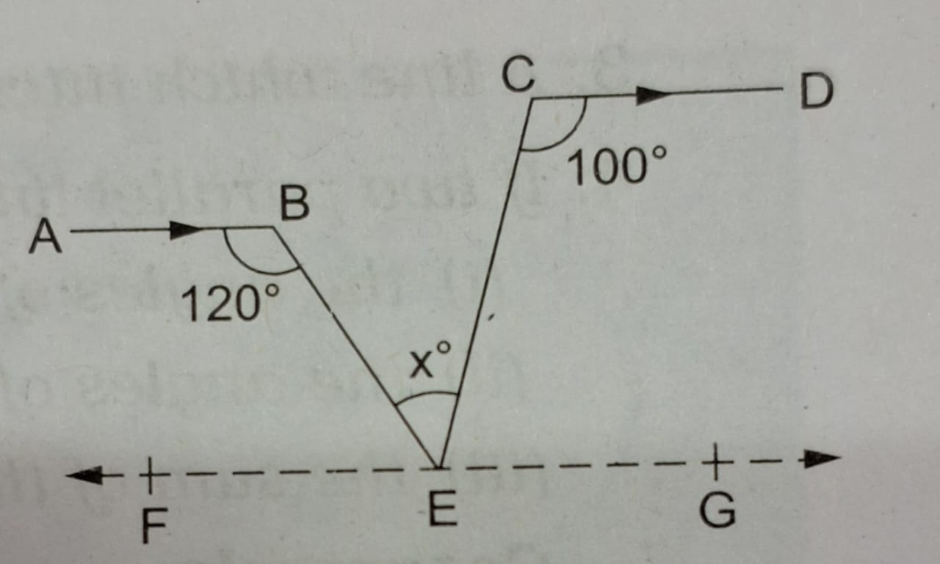 4 marks

Q 4. (i) Find the value of $\left(-8u^{2}v^{6}\right)×\left(-20uv\right) for u=2.5 and v=1$ 2 marks
(ii) Subtract the sum of $\left(8a-6a^{2}+9\right) and \left(-10a-8+8a^{2}\right) from-3.$ 2 marks

